HOSPI-TEL SHOWER/CUBICLE CURTAIN MFG NOW CLOSED DOWN IN USA, NJ
www.hospitel.com CONTACT: David Freedland for more information and pricing.
dfreedland54@gmail.com Tel. 1-908-672-1671
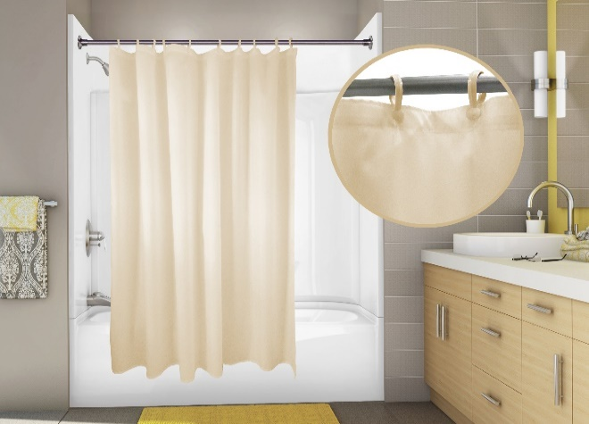
Traditional Nylon Shower Curtain
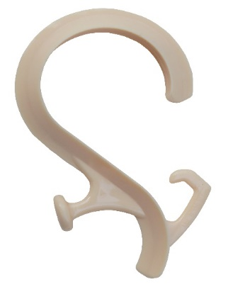
Tandem Hook

Auto Topper
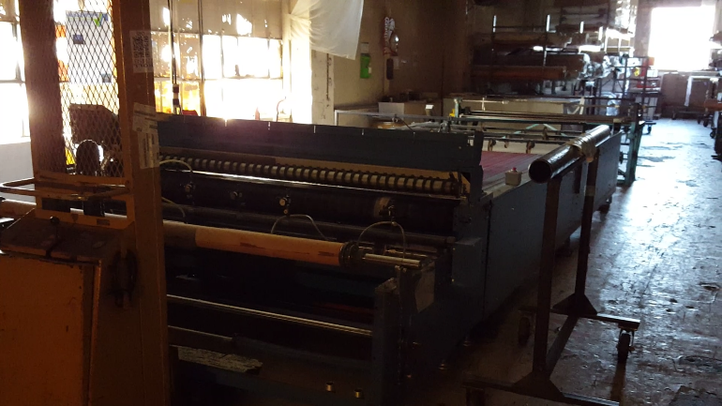
Auto cutter

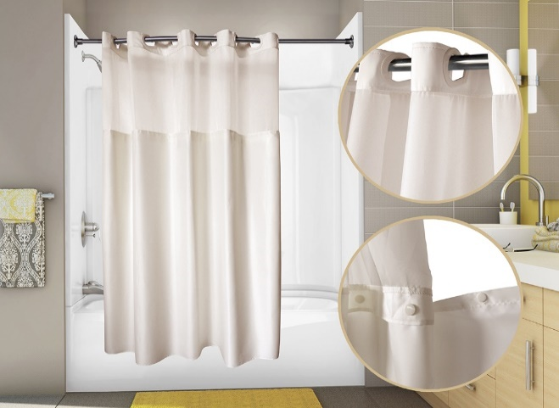
PreHooked™ Duet with snap liner
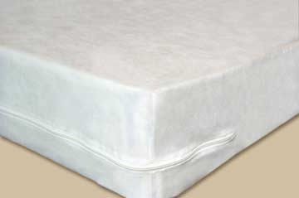
Mattress Encasement Bed bug Certified
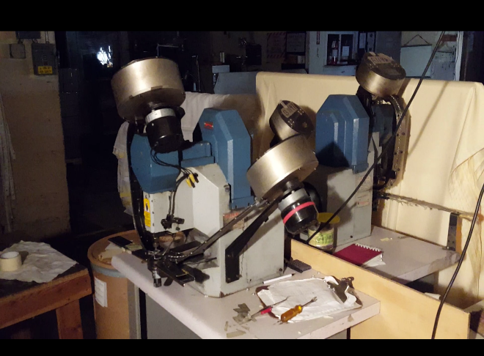
Grommet Machine
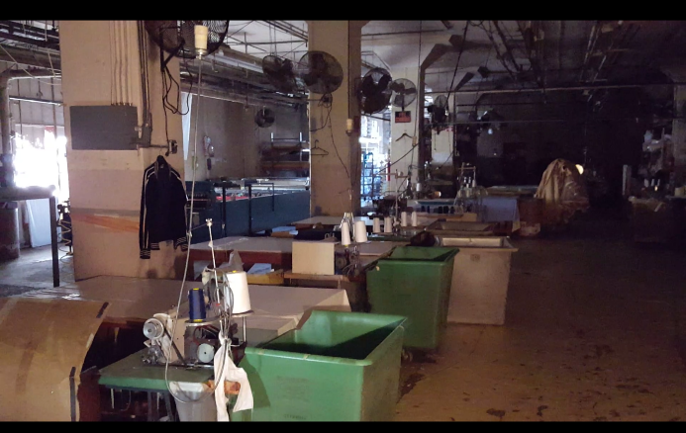
Sewing Line 1

